MACH4METAL

metalworking machinery
Transito 21
6909 DA BABBERICH Netherlands
Tel. +31 (0)316-247123
Fax: +31 (0)316-247956
info@mach4metal.com
www.mach4metal.com

Bank No : 66.52.13.883
IBAN : NL33 INGB 0665 2138 83
BIC : INGBNL2A

ROUNDO CNC 4 roll 1000 x 35 mm
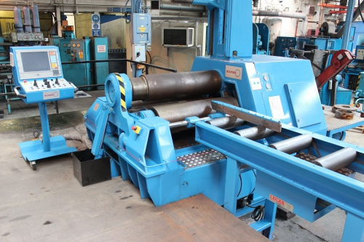
- Make : ROUNDO Sweden
- Typ : PAS 340
- Serial . No : 098529
- Age : 2009

- Bending length : 1.000 mm
- Thickness by Ø 3000 : 35 mm
- Thickness by Ø 1700 : 32 mm
- Thickness by Ø 1000 : 30 mm
- Pre bend : 25 mm
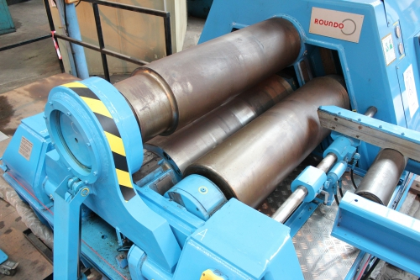

- Top roll Ø : 340
- Side roll Ø : 290
- Power kW : 34

- Dimensions
- Length : 3.390
- Width : 1.900
- Height : 1.880
- Weight : 18 Ton
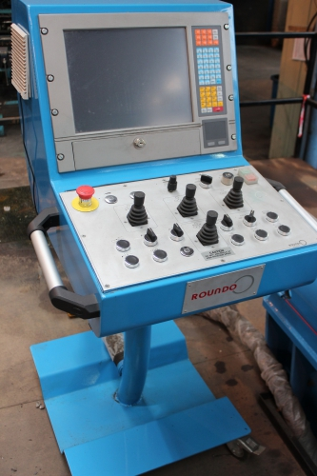
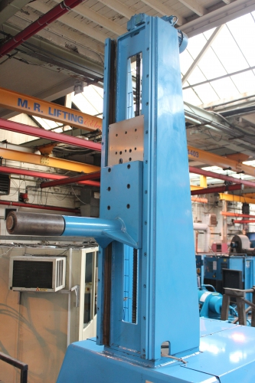
- Incl. driven top support
- Incl. driven roller track feeding side

- Roundo wCNC² CNC Control TFT
- Flying production
- Teach-in feature
- Graphical program simulation
- Drill-down function advanced program
- Bending wizards for easy Programming
- Interpolation function

Please Note: The above information has been obtained to the best of our ability and belief from, and from the manufacturers where possible. It is given in good faith, but its accuracy can not be guaranteed. Accordingly, it will not form a representation or constitute contractual terms. We advise you to check any vital details!

